Introduction to Work:

The goal of this work is to create independent programs which run simultaneously and simulate the function of preparing a salad on behalf of the chain "Quick Salad". So you have to implement at least 2 types of processes ( templates) where each has a different role. The 2 types of processes are:

- The Salad Manager ( chef) coordinates and directs the production of salads with the help of employees called salad makers.

- The salad makers ( saladmakers) expect to be given some of the materials to move on

in the creation and composition of salads.

In this task, you will need to implement 1 manager and 3 salad makers who will work simultaneously to create a certain number of salads consisting

of tomatoes, peppers and

onions.

In the task you should:

- use semaphores to have a successful collaboration between independent processes, shared memory segment to properly serve the stakeholders, as well as to create relevant structures where you think they are needed,

- you have all the processes to attach (ie, attach) the above shared memory segment so that

can access their variables / structures of interest, and

- use POSIX Semaphores to implement your solution that will include relevant calls P () and V (), for tasks lasting periodically defined time periods.

Should show correctness of your solution with respect to simultaneous execution of the processes that take part in the solution you provide in a way that is immediately understandable / measurable.

Procedural:

Your program should be written in C ( the C ++ if you want but without the use STL / Templates) and run on Linux

Your source code must consist of at least two ( and preferably more) different files and should necessarily to be used separate compilation.

1

The Composition of Simultaneous Processes:

Figure 1 shows a representative picture of the problem we are trying to solve with simultaneous processes: to prepare a certain number of salads, each of which consists of 1) 1 tomato, 2) 1 green pepper, and 3) 1 small onion. A team of 4 processes works to create the salads, one of which is the "manager" ( chef) and the other 3 "salad makers" ( salad-makers).

The manager has at his disposal all 3 above materials in bins located behind or next to him and are constantly supplied (simple third party employees). Every salad maker has at his disposal only one material in a basket that is next to him that is also constantly fed. So a salad maker expects to get the 2 he's missing in order to make the salad, a job that takes a random amount of time. Once he has cut all the ingredients in this random space, he places the pieces on a plate and gives them to a waiter (one is always available).

Figure 1 gives an overview of what is shared between the manager and the salad makers.
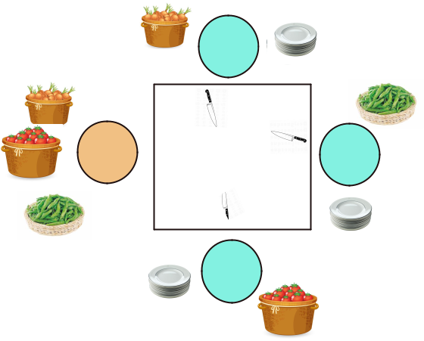

Salad Maker1

Chef | Salad
Chef | Maker2

Work

bench

Salad

Maker3

Figure 1: The simultaneous production of salad for the chain "Quick Salad".

The assumptions / constraints for the 4 simultaneous processes are:

- Vegetables in baskets as well as dishes for salad makers are always available.

- Each salad maker uses the material to which he has direct access and waits for the ingredients he does not have to come to the table (to get them). For example, salad maker 1 is waiting to be 'notified' of the arrival of 'tomato and pepper' on the work table.

- When a salad maker has all the ingredients at his disposal, he starts cutting them to create a salad. This process takes some time and when completed, the salad maker delivers the dish to the always available waiter.

- The manager has 3 baskets at his disposal and every time he takes them random materials from 2 baskets

and puts them on the table (he has only 2 hands!). Each combination of vegetables can supply one particular salad maker at a time. The manager 'notifies' the salad maker to get the ingredients he needs. For example if he chooses tomatoes and onions then he notifies the salad maker 2. Once the ingredients are omitted by the salad maker the manager continues in the same pattern until the preparation of the salads to be done is completed.

The Demand & Results

Independent programs for the manager and clients must be synchronized with POSIX P () / V ()

2

and have access to any structure / variable needed in the shared memory ( shared memory).

You are free to adopt a (limited) number of semaphores, and auxiliary variables / structures for your programs. The program would be a good idea chef to create the shared segment, initializes structures and / or variables. The ID of the common section may be made known in its executables
saladmakers from the command line of the latter. The program chef could also initialize the signals needed for the solution we want.

In the shared segment there is expected to be a variable which at any given time indicates the number of salads you should yet to be prepared to end the collaboration. The saladmakers complete when the variable in question has the value 0.

Your programs should generate outputs that with easily understood be able to show the correctness and at the same time the execution of the involved processes.

When your programs end, it must be done cleaning and deletion of shared segment and the semaphores used. The release ( purging) such resources is imperative. Otherwise there is a risk that the core may not be able to serve future needs.

Application Dial Bar:

The application chef can be called as follows on the command line ( tty):

. / chef -n numOfSlds -m mantime

where

- chef is the executable you will create,

- The flag - n numofSlds provides the number of salads to be prepared, and

- The flag - m mantime provides the time available to the manager to get one 'breath' between successive deposits of materials on the table.

The program saladmaker can be called as follows:

. / saladmaker -t1 lb -t2 ub -s shmid

where

- saladmaker is the executable that implements the function of the salad maker,

- the flags - t1 and - t2 determine the amount of time the salad maker needs to do his job. Thus, a duration between the limits is randomly selected by the program lb and ub), and,

- The flag - s shmid gives the key that the shared memory compartment has (and where semaphores are located and any other ancillary structure / variable required).

The order in which the flags appear is not predefined. Obviously you can use more flags in the above programs to make it easier.

Finally, it would be good - and for reasons of confirmation - to have a mechanism logging in the form of a append-only file for the work that everyone does. Here, all the activity of each process so far is captured so that you have an easy way to see what is happening overall with regard to simultaneous execution of programs.

Results of the Processes:

THE chef must provide at least the following information:

1. Number of salads made in total.

3

- The number of salads that each salad maker has made.

- Chronicles logs which for each salad maker give the timeline of his activity (1 such file for any salad maker).

- List of time intervals in which 2 or more processes operate simultaneously.

Limitations on the Programs You Will Write:

1. You cannot do pre-allocate any space since structure(s) should be able to grow with virtually no limit on the number of records they can store. Using static tables / structures that are bound during the symbol translation of your program is not an acceptable option.

- For any design choice you adopt, you must justify it in your report.

- Before the execution of the programs, the content of the structures is released in a gradual and controlled way. Equally important is the code for him chef before finishing to thoroughly clean parts of it shared memory so that this resource is properly returned back to the kernel.

- If any part of your code comes from a public source, you should to give

reference to that source whether it is a book, notes, Internet URL etc. and explain exactly how you used that reference.

5. You have complete freedom to choose the way in which you will eventually implement auxiliary structures.

What to Deliver:

- A brief and comprehensive explanation of the choices you have made in designing your program (2-3 pages in ASCII text are sufficient).

- Definitely one Makefile ( which can be used to do it automatically compile of

your program). More details about ( Makefile) and how this is created are given on the course website.

3. One tar-file with all your work on a list that probably will contain all your work ie. source files, header files, output files ( if any), and your report.

Other Important Remarks:

- Your program should run on Linux systems of the department otherwise can not be paid.
- In no case the Windows is not eligible platform for presenting this task.
- Only separate compilation is accepted
- Comments everywhere

4

